**Question 8.4**

1. Looking at the residual plots for Age, I see a consistent trend of variation in the residuals. However, for Income, the variation in residuals rises with an increasing value of income. In other words, these graphs tell me that there is Heteroskedasticity present in the data.
   1. In each case, the sign of the estimates does not change, so I can say with certainty that the miles travelled in a vacation are positively related to age and income, and negatively related to the number of children in the family.
   2. The White-corrected Standard Errors are higher than the standard OLS ones. This changes my estimation of the precision of the estimates because for the same significance level, I will now have a wider interval estimate. However, the decrease in precision also comes with a decrease in the inaccuracy of the data. It is practically the same tradeoff as that between significance level and precision.
   3. Not right now. I would need either a White Test of a residual plot of the generalized estimated to say for sure. As of now, I cannot say with certainty that the generalized least square estimates are better than either of the other two. In-fact, if it turns out that the form of variance has been wrongly estimated, then these might be worse than the other two.

**Question 8.12**

1. Richer countries can have a greater gap of expenditure between say public schools (which tend to charge less) and private schools (which tend to charge more). Depending on the country’s policy, the y variable can vary drastically whereas poor countries would not have the option of for-profit schools and would exhibit very little variation.
2. Below is the residual plot:

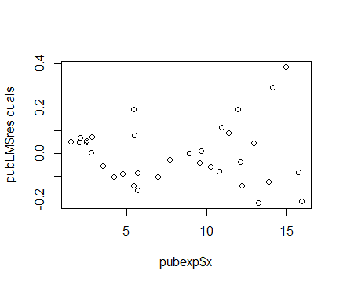

1. I get a p-value of 0.002782 and can reject the Null that there is no Heteroskedasticity, in favor of the alternative that there is Heteroskedasticity.
2. The 95% confidence interval without White’s correction is:

[0.06302216,0.08332384]

and with White’s correction is:

[0.06023073,0.08611567]

Clearly, the interval has become wider with White’s correction – the same as in the previous question. The CI without correction is narrow but gives an inaccurate estimate.

1. The generalized least square interval estimate is [0.06226104,0.08049296]. It is narrower than the interval found in part d., but upon checking the residual plot, it is evident that the heteroskedasticity has not gone down much.

